

**IMPLEMENTATION OF DATABASE USAGE IN CONCERT TICKET SALES**

Group 7

Names : Leann Nataly Kenan Pakpahan

Salma Aufa Ramadhanti Iswara

Techi Kariska Sari

Class : 1CC8

**CEP CCIT**

**FAKULTAS TEKNIK UNIVERSITAS INDONESIA**

**2023**

**Developed by**

1. **Leann Nataly Kenan Pakpahan**
2. **Salma Aufa Ramadhanti Iswara**
3. **Techi Kariska Sari**



**PROJECT ON**

**IMPLEMENTATION OF DATABASE USAGE**

**IN CONCERT TICKET SALES**

**Implementation of Database Usage**

**in Concert Ticket Sales**

Batch Code : 1CC8

Start Date : January 11, 2024  
End Date : January 24, 2024

Name of Faculty : Tri Agus Riyadi, S.Kom, M.Kom

Names of Developer :

1. Leann Nataly Kenan Pakpahan
2. Salma Aufa Ramadhanti Iswara
3. Techi Kariska Sari

Date of Submission: January 24, 2024

**CERTIFICATE**

This is to certify that this report titled “Implementation of Database Usage in Concert Ticket Sales” embodies the original work done by Leann Nataly Kenan Pakpahan, Salma Aufa Ramadhanti Iswara and Techi Kariska Sari. Project in partial fulfillment of their course requirement at NIIT.

Coordinator:

CEP CCIT



**ACKNOWLEDGEMENT**

We are grateful to Allah, the Almighty God, for giving us the abilities to fulfill our work without incident. Blessings and greetings are also sent to Muhammad SAW, our final and greatest prophet. Not to mention, we are grateful for our parents who have continued to support us both morally and financially till this point. We would like to thank Tri Agus Riyadi, S.Kom, M.Kom. as our supervisor who always helps us to finish this paper. Also acknowledged are our friends who have assisted us up until quite recently.

This paper was prepared to fulfill our project assignment as CEP CCIT FTUI students. The topic that will be discussed in this paper mechanism Implementation of Database Usage in Concert Ticket Sales works such as analysis data, PivotTable, PivotChart Analyze, Slicer and many more. We hope this paper will be beneficial to all those who read, especially in education of information technology.

The author realizes that this paper is far from perfect, so it will be very helpful if colleagues and supervisors are willing to provide suggestions and criticism for the perfection of this paper.

**SYSTEM ANALYSIS**

**System Summary:**

The implementation of a database system for concert ticket management aims to enhance efficiency, accuracy, and organization in handling ticket sales and related information. This system employs a robust database structure to store and manage critical data associated with concerts, tickets, and customer interactions.

This ticket management including the data of schema installment, product detail. This project also using like PivotTable, PivotChart, hyperlink, slicer etc. The purpose of this project is to make a compact version of financial repost using excel so that when we inputting data it will be more effective and also, we can save a lot of time because we are working with excel.

**Excel Project Name : Ticketing Sales**

**List of Sheets:**

1. Product Name
2. Startup Capital
3. Item List
4. Stock
5. Transaction
6. Dashboard
7. Relation

**EXCEL TABLE DESIGN**

**Describe and explain the excel functions used**

1. Count and Sum

Here we can count and sum based on one criteria or multiple criteria

1. Logical

Excel’s logical functions, such as IF, AND, OR and NOT.

1. Cell References

Understand the difference between relative, absolute and mixed reference.

1. Text

Excel has many functions to offer when it comes to manipulating text strings.

1. Financial

This chapter illustrates excels most popular financial functions.

1. Statistical

An overview of some very useful statistical functions in excel.

1. PMT

One of the financial functions, calculates the payment for a loan based on constant payments and a constant interest rate.

1. What-If Analysis

Is the process of changing the values in cells to see how those changes will affect the outcome of formulas on the worksheet.

**IMPLEMENTATIONS**

**ACTIVITY LIST**

1. PRODUCT NAME

This table shows the detail about the product (ticket), but this table is not for public, this table is for staff, and management of the agency only because this table include a private information such as product id, product name, percentage purchase, purchase price per unit, percentage profit per unit, selling price per unit, stock and total purchase price.

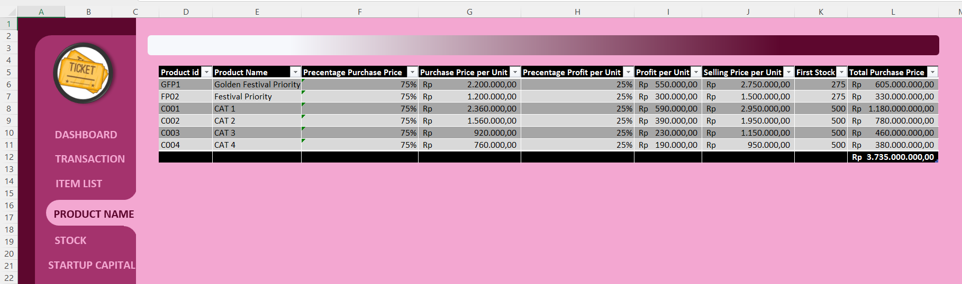 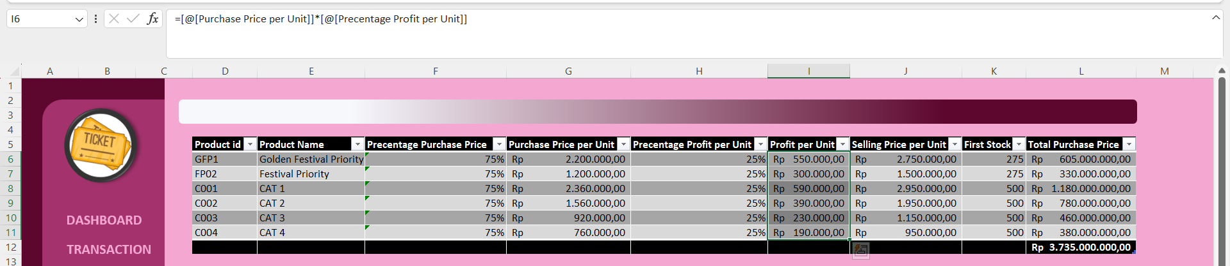 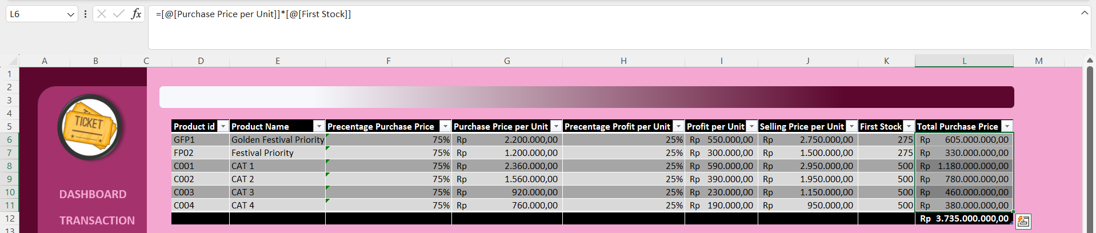

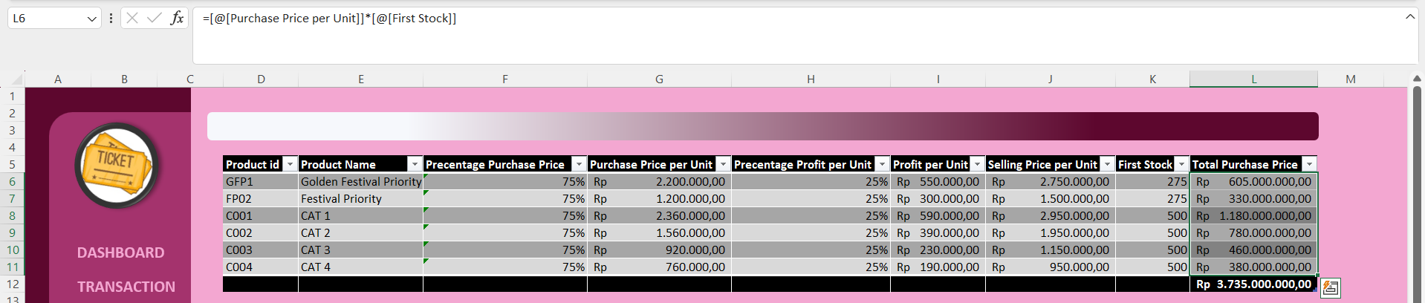

**ACTIVITY LIST**

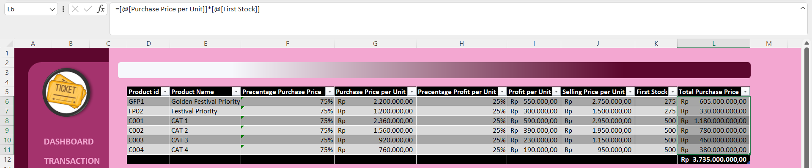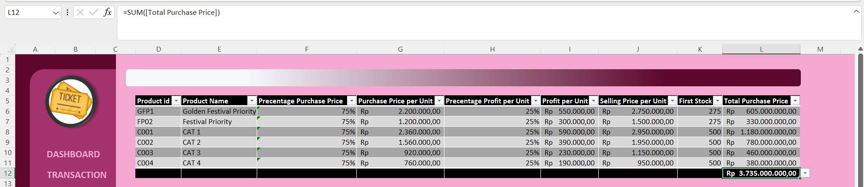

1. STARTUP CAPITAL

This table is the report of modals that used in ticket agency. This table shows products that needed in agency, such as CPU, Monitor, Keyboard, Mouse, Printer, Wristband Paper. This table also shows annual expenditure such as Employee’s Salary, Rent Cost, Electricity Cost, and Internet Cost.

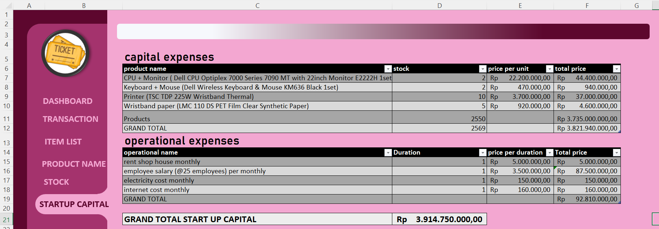

**ACTIVITY LIST**

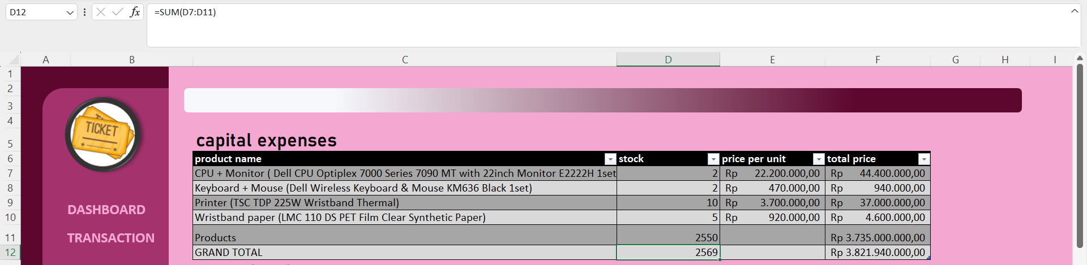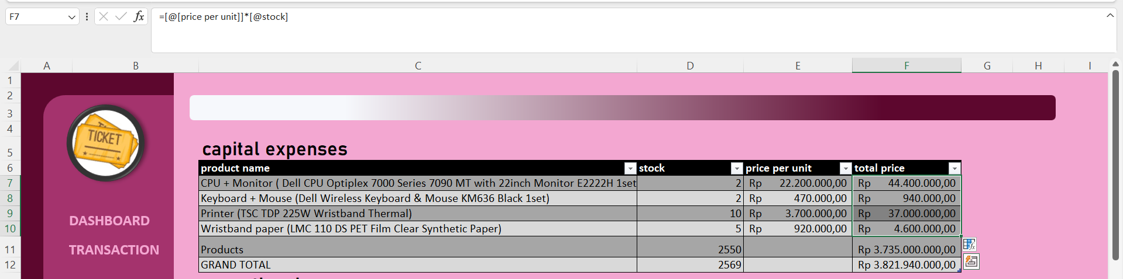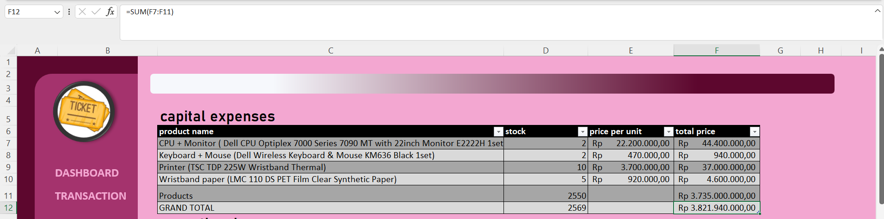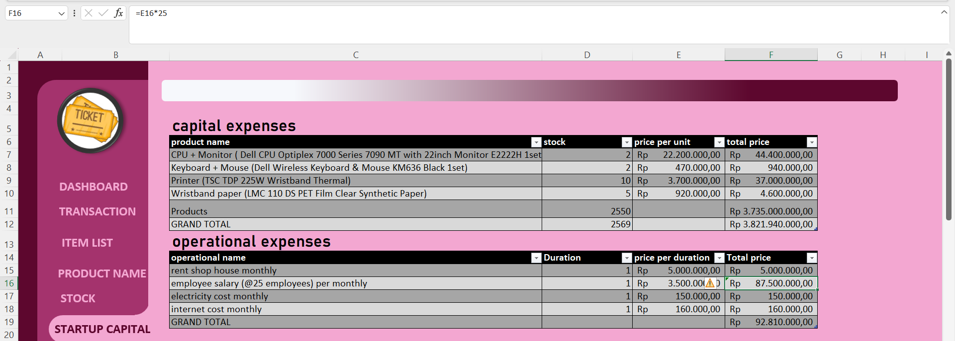

**ACTIVITY LIST**

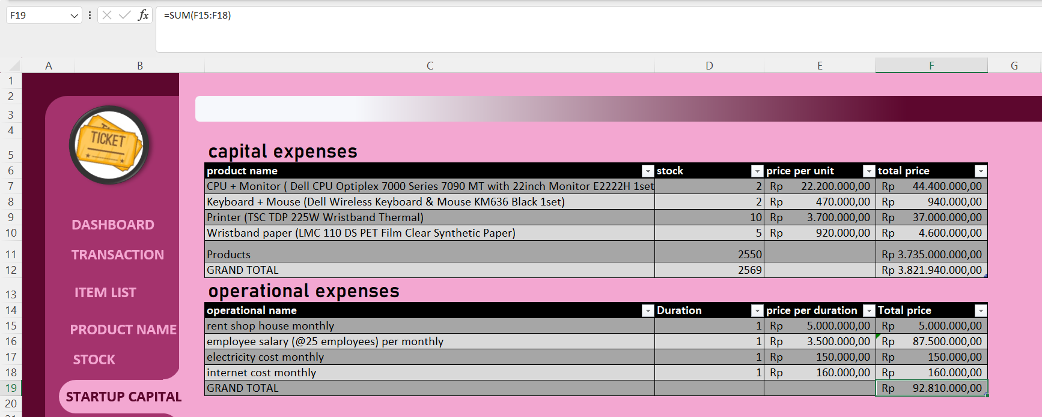 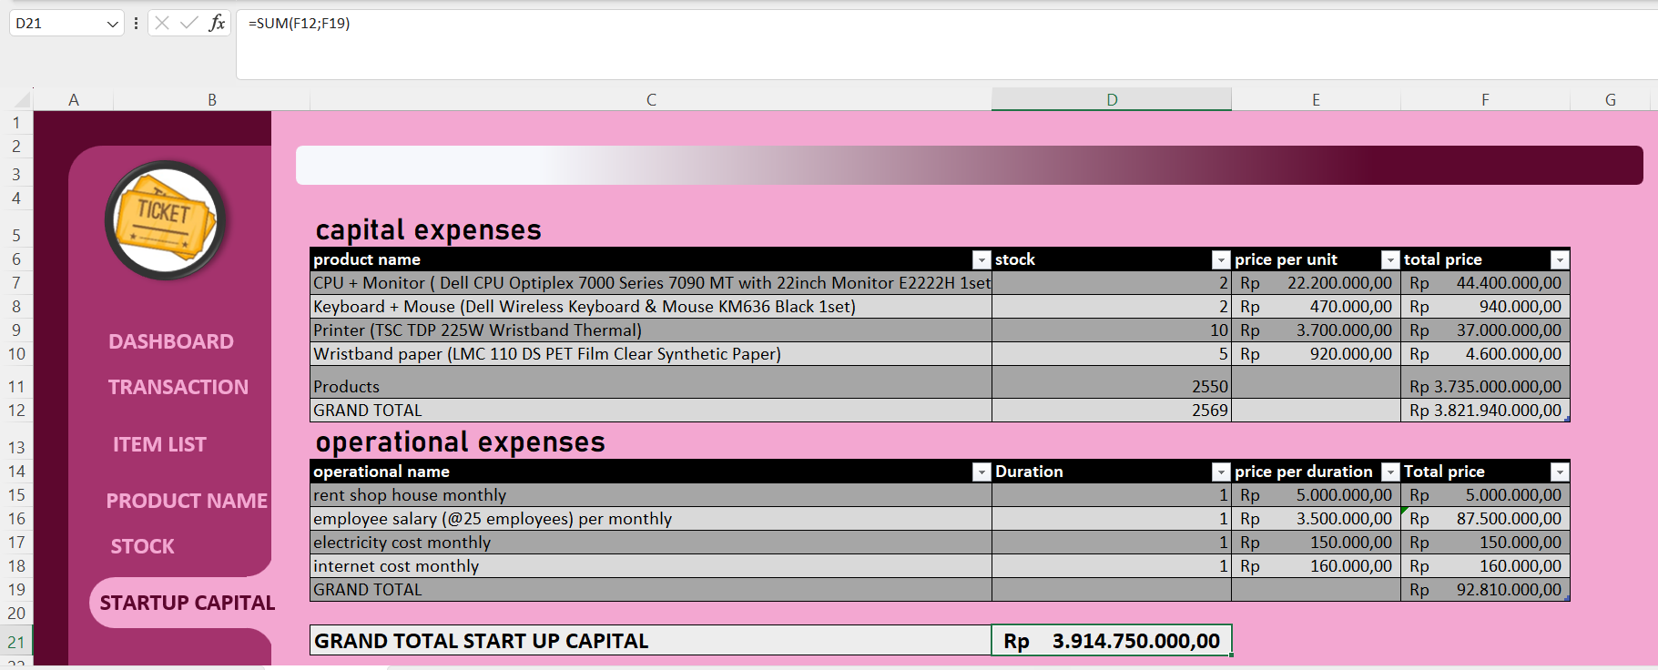

1. ITEM LIST

This table is shows the general of product item, the purpose of this table is to facilitate customer so they won’t be confused to see the products in Agency Ticketing Sale.

**ACTIVITY LIST**

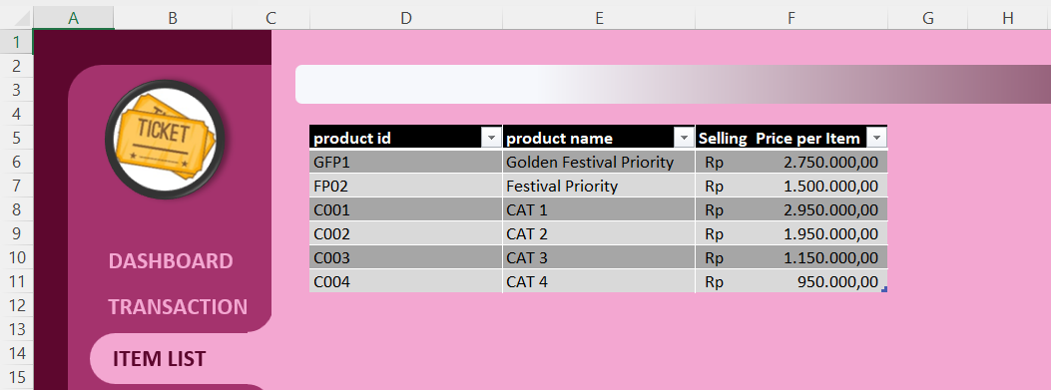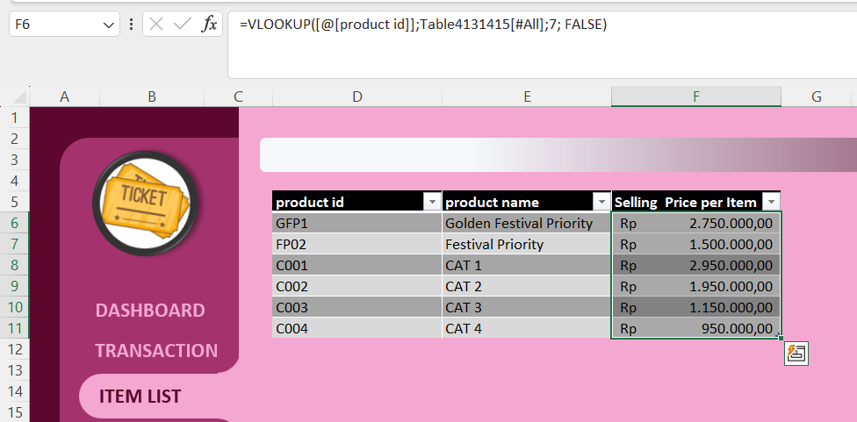

1. STOCK

This table serves to identify the remaining stock of ticket sales and contains the stock of ticket sales and the remaining stock that has been sold out. in this table there is a product id, product name, first stock and left stock.

**ACTIVITY LIST**

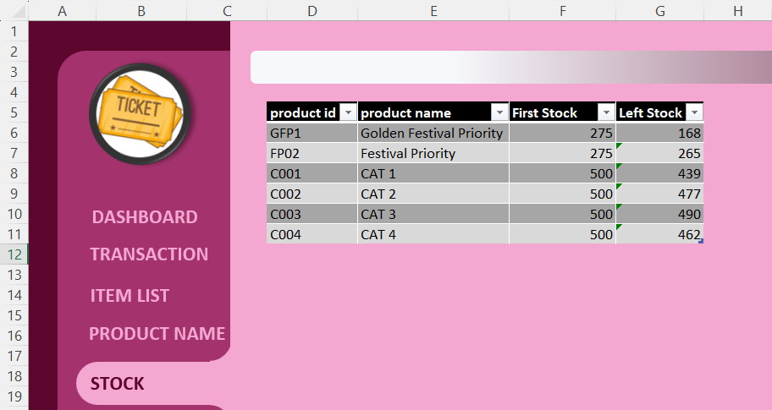 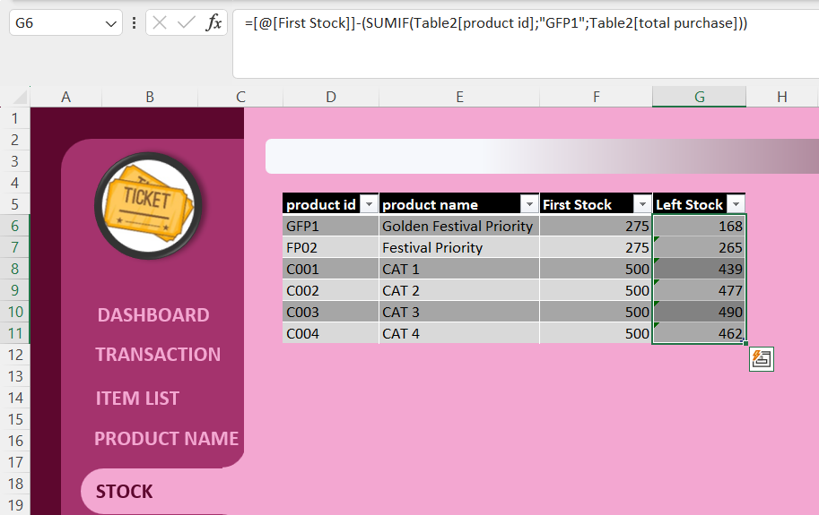

1. ITEM LIST

This table is shows the general of product item, the purpose of this table is to facilitate customer so they won’t be confused to see the products in Agency Ticketing Sale.

**ACTIVITY LIST**

1. TRANSACTION

This table shows the report of the customer purchases, the purpose is to show the product that already selled in 3 days, also to show how much product that left, the table also show the detail about when the transaction happened.

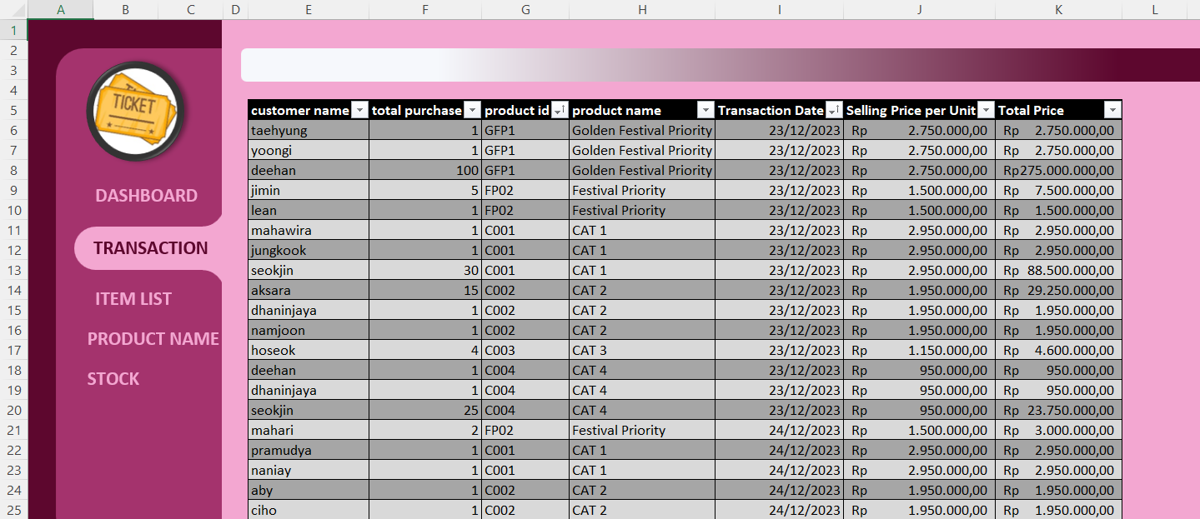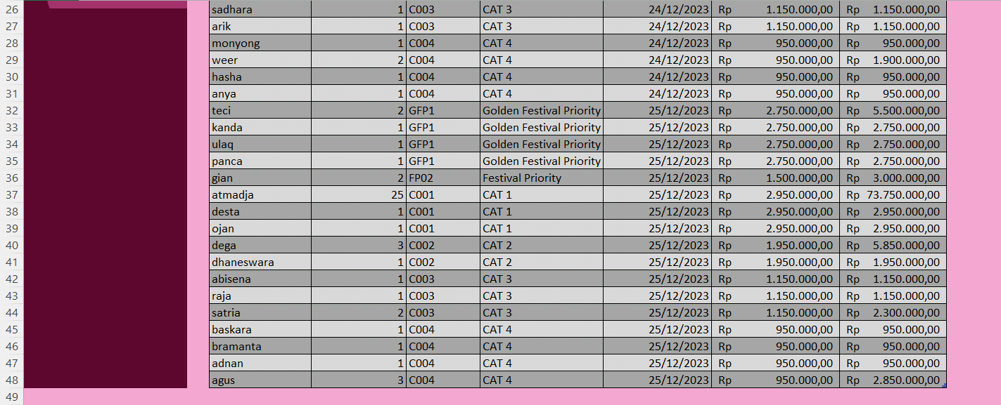

**ACTIVITY LIST**

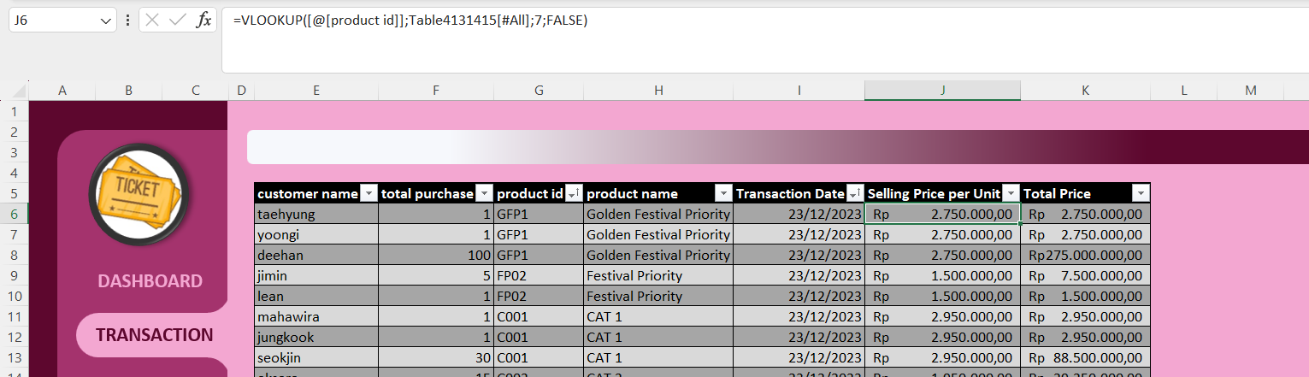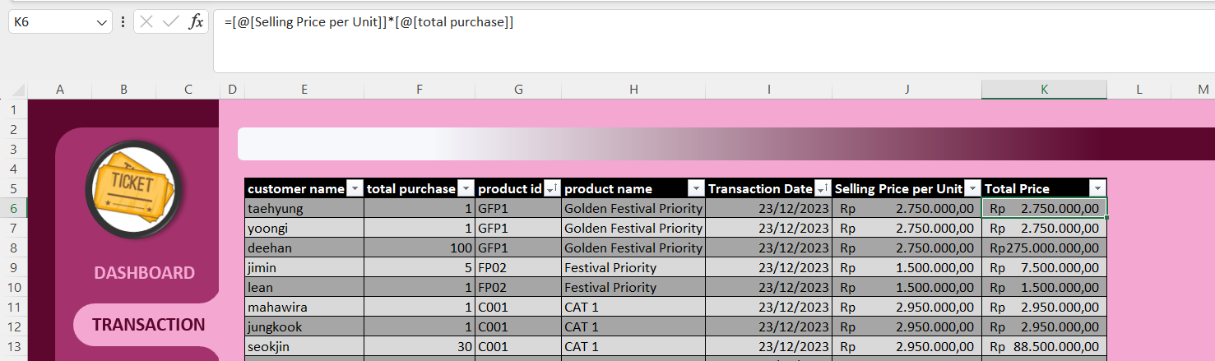

1. DASHBOARD

Excel dashboards are used to present information in a concise and easy-to-understand manner through visual elements such as graphs, tables, and other graphical elements. in this dashboard there are PivotTables, PivotCharts and also Slicers.

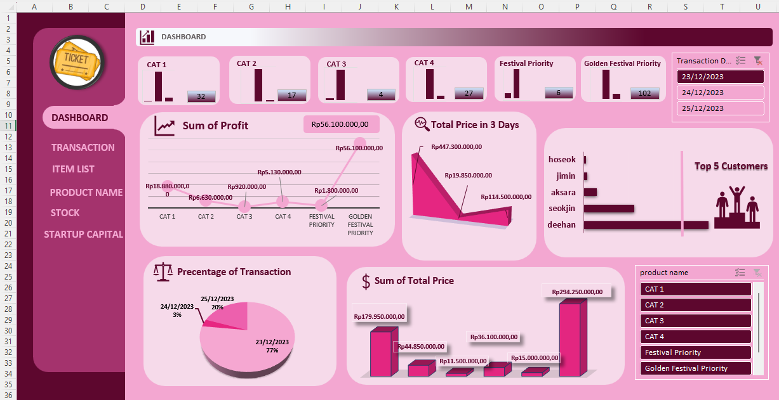

**ACTIVITY LIST**

1. RELATION

This Relation between tables.

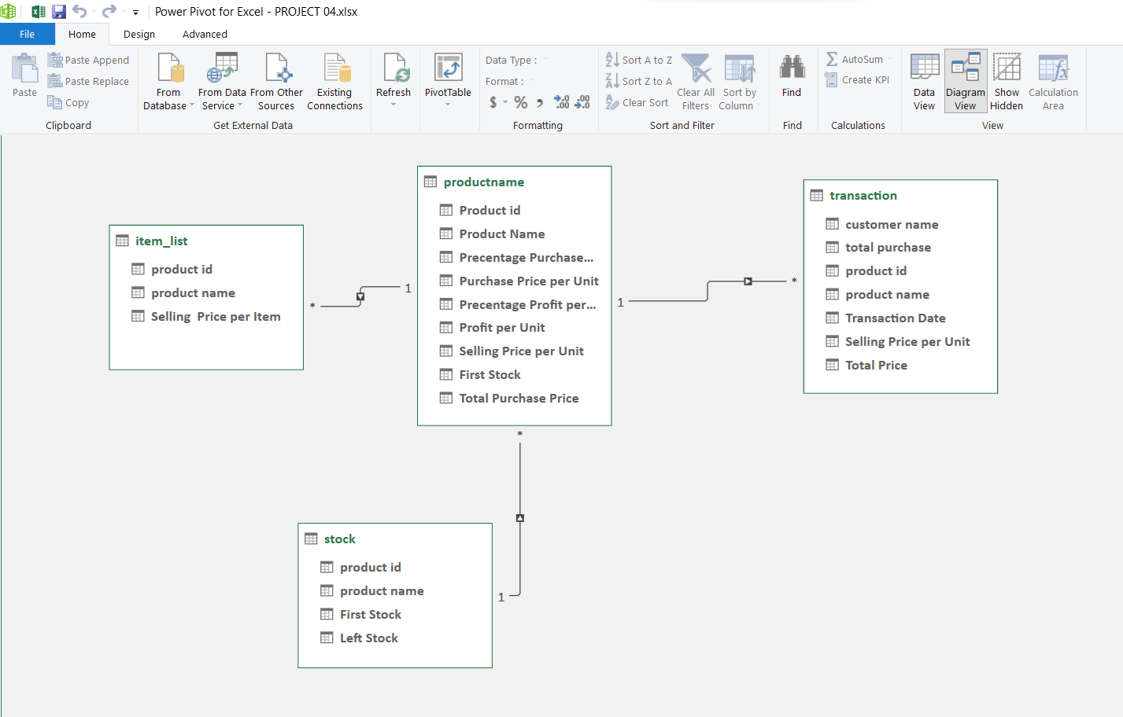

**Hardware :** Acer Aspire A715 – 76G 12th Gen Intel(R) Core(TM) i5-12450H

2.00 GHz 8,00 GB 64-bit operating system

**Operating System :** Windows 11 Home Single Language

**Software :**  Microsoft Excel, Microsoft Word

|  |  |  |
| --- | --- | --- |
| **PROJECT FILE DETAILS** | | |
| **No.** | **File Name** | **Remarks** |
| 1. | Project4.xlsx | Made with Microsoft Excel |

**CONFIGURATION**